DIPSITE GOLFING FRATERNITY  PROPERTY FACT SHEET · ANNUAL GOLFING BASH 2025 · GOLS PARTNERSHIPS — WEEK 1
  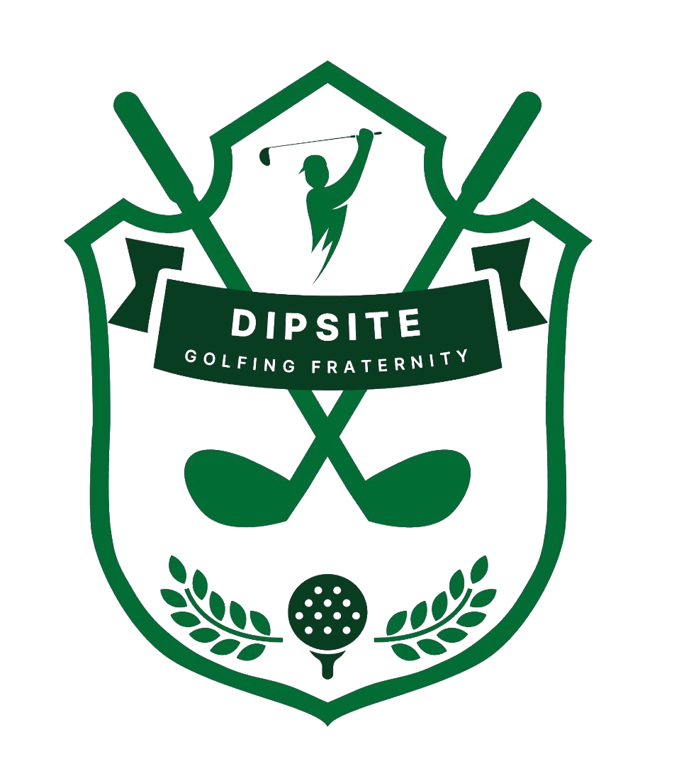

FORMAT | Annual golfing bash bringing together DPS (Delhi Public School) alumni — CEOs, entrepreneurs, investors and industry leaders — for a day of sport, camaraderie and connection.  Positioning: “Where Influence meets Affluence.”
TOURNAMENT DETAILS | Friday, 24th October 2025 | Shotgun Start 12:30 PM  - Field Size — 100–115 · Expected Attendees — 300+  - Gala Night & Prize Ceremony — 7:00 PM · Celebrity Entertainment  - Venue — Qutab Golf Course, New Delhi
AUDIENCE PROFILE | - DPS alumni — CEOs, entrepreneurs, investors, industry leaders  - Median age 35+ (97% male attendees) · Avg. disposable income INR 75 lakh+  - Occupation: C-suite, senior management mix, entrepreneurs, defence and bureaucrats  - Residence: Delhi NCR  - Lifestyle: 50 lakh+ automobile owners, Amex/Citi Gold cardholders, elite golf club members, posh localities, DPS alumni
MEDIA COVERAGE | No PR or media coverage identified in materials reviewed to date.
SPONSORS IDENTIFIED (2023 EDITION) | Identified from 2023 Annual Golfing Bash event signage/photography in the deck — no sponsorship tier stated; confirm before use in outreach.
  IHCL | MG | SIX5SIX | Envee Optix
  Hospitality Partner
  The Advanced Gloster | Adhiraaj Valley | Fresh Street Banquets
  Housing Partner
SPONSORSHIP RATE CARD (2025) | Title Sponsor — INR 10 Lakhs + GST (1 slot)  - Naming rights · 4 playing slots · logo on prize backdrop, tee boards, bag tags & goodie bags · 6 runner boards · 8 Instagram + 8 LinkedIn posts  Gold Sponsor — INR 5 Lakhs + GST (2 slots)  - 2 playing slots · logo on prize backdrop, tee boards & goodie bags · 3 runner boards · 4 Instagram + 2 LinkedIn posts  Silver Sponsor — INR 3 Lakhs + GST (3 slots)  - 1 playing slot · entrance arch logo · 2 runner boards · 2 Instagram posts  Car Sponsor — INR 5 Lakhs + GST (1 slot)  - 2 cars on display · prize backdrop & tee board logo · 4 runner boards · 4 Instagram + 4 LinkedIn posts  Skill Prizes — INR 2 Lakhs + GST (5 slots)  - Longest Drive · Closest to the Pin · Reach the Stars · Putting Champion · Straightest Drive  Sold/open status not stated in materials — confirm directly before outreach.
KEY DIFFERENTIATOR | Direct access to a closed, high-trust DPS alumni network — CXOs, investors, industry leaders — positioned explicitly around “influence meets affluence.”
Sources: DGF Sponsorship Deck – 2025 (via Meenakshi/Yuvraj, 30 Jul 2026); 2023 event signage/photography included in the deck.

